**50.012 Networks Lab 4**

**Q: What is the normal time required to download the webpage on h1 to h2?**

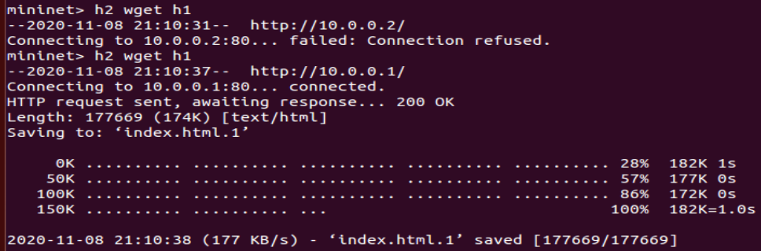

Time taken to download the webpage = 1.0s

**Q: What was your initial expectation for the congestion window size over time?**

The congestion window size should increase (additive increase) over time until loss is detected (multiplicative decrease) where it decreases, and this behaviour should be cyclic (alternating increase and decrease).

**Q: After starting iperf on h1, did you observe something interesting in the ping RTT?**

The ping RTT increases to about 800ms, and then drops sharply to about 400ms. This cycle repeats.

**Q: After starting iperf on h1, why does the web page take so much longer to download?**

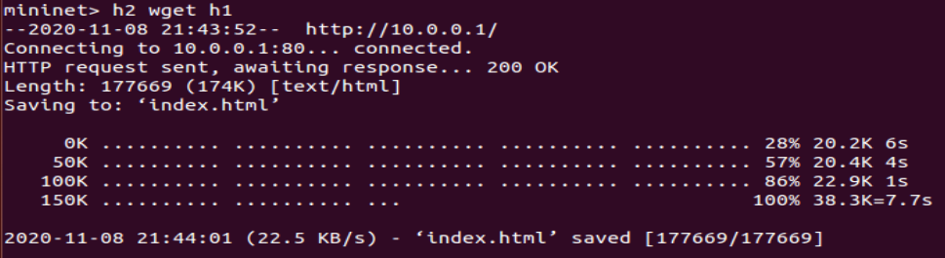

Time taken to download the webpage = 7.7s

Currently, as there is a “long-lived video flow” ongoing, the traffic is congested. So when the command “h2 wgets h1” is executed, the packets sent from the server for the web page download will have to compete with the current packets flowing for the “video” in the network traffic. As the traffic is congested, the packets for the webpage download will have a higher delay as to when the traffic is not congested.

**Q: Please provide the figures for the first experiment (with qlen 100). Please comment on what you can see in the figures.**

Switch Queue Occupancy:

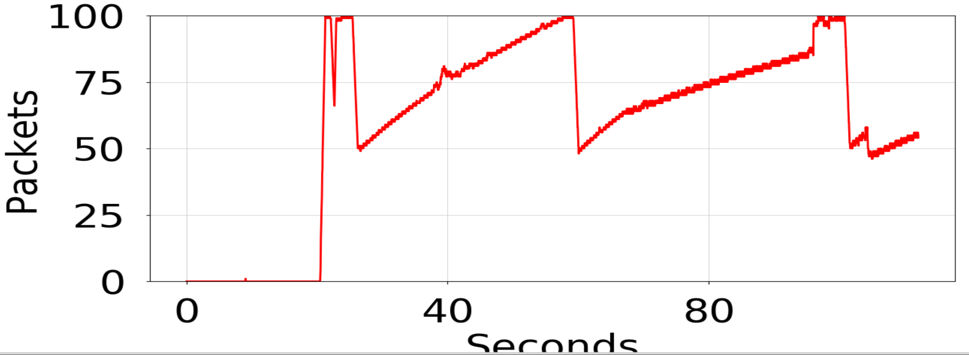

TCP CWND for iperf:

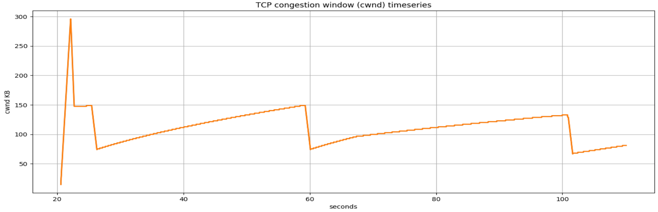

TCP CWND for wget:

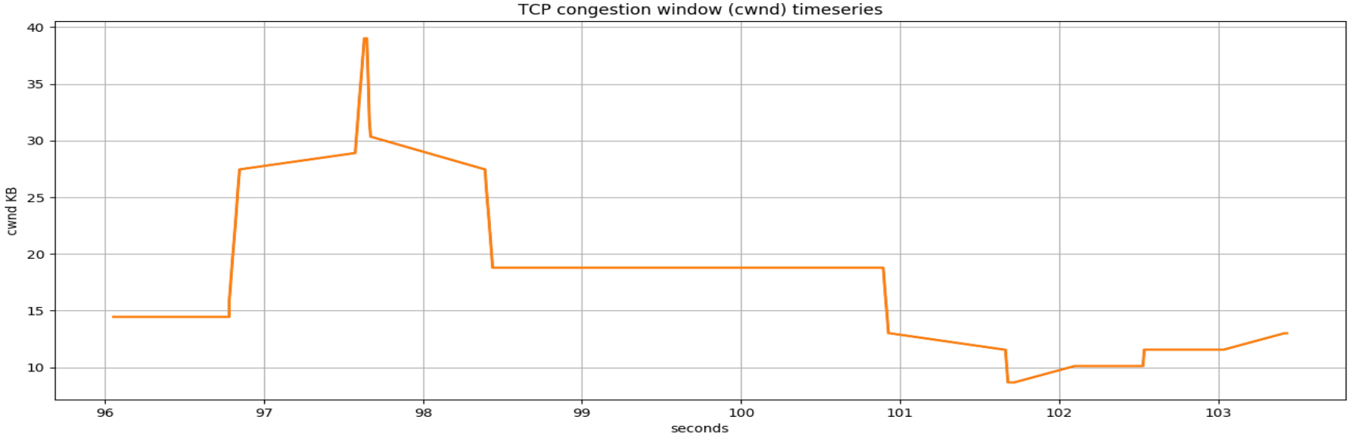

The figures generally follow a “saw-tooth” behaviour, due to additive increase and multiplicative decrease (when loss occurs).

For the first figure, the switch queue occupancy has its peak at 100 packets.

For the second figure, the TCP CWND for iperf had a relatively consistent cwnd peak of 150kB (ignoring first 22 seconds or so), until about t = 96.7 to 100.9 seconds where its rate of increase decreases and it reaches a slightly lower peak of 130kB. This corresponds to the time where the wget happened, referring to the third figure where the TCP CWND for wget is relatively high. This is because packets for the “long-lived video flow” and the wget are competing in the network traffic.

**Q: Please provide the figures for the second experiment (with qlen 20). Please comment on what you can see in the figures, and what is different (and why?)**

Switch Queue Occupancy:

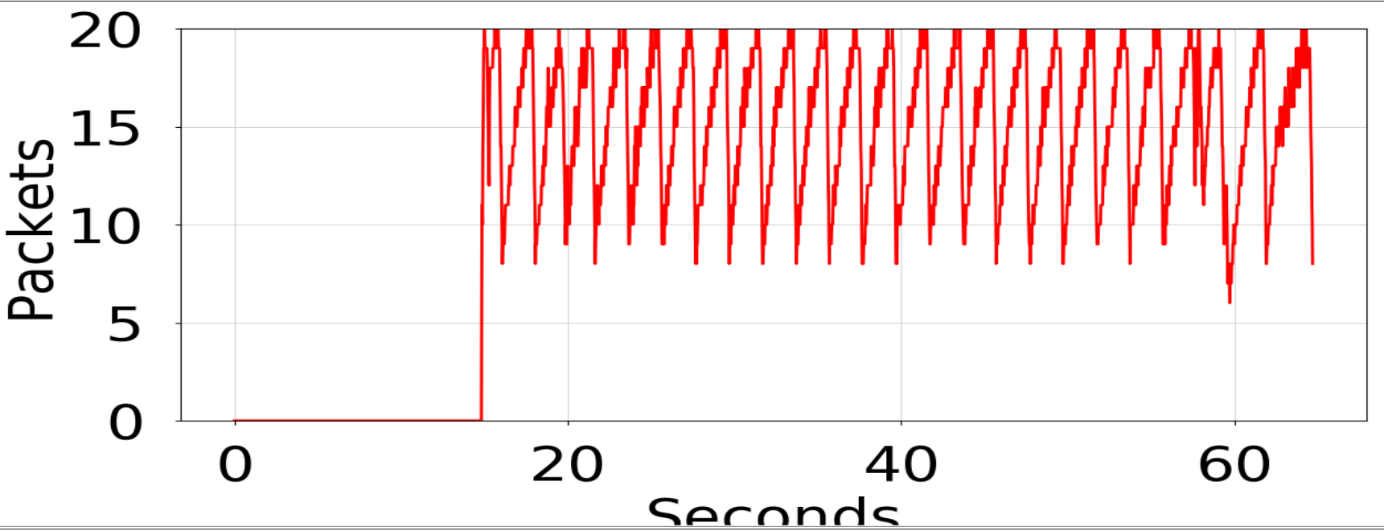

TCP CWND for iperf:

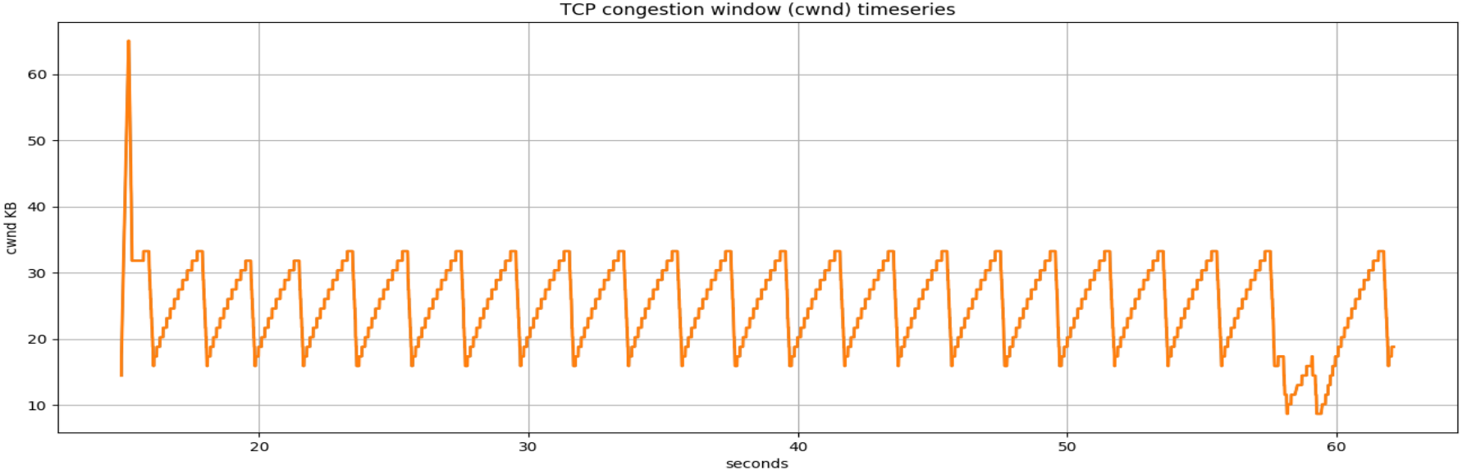

TCP CWND for wget:

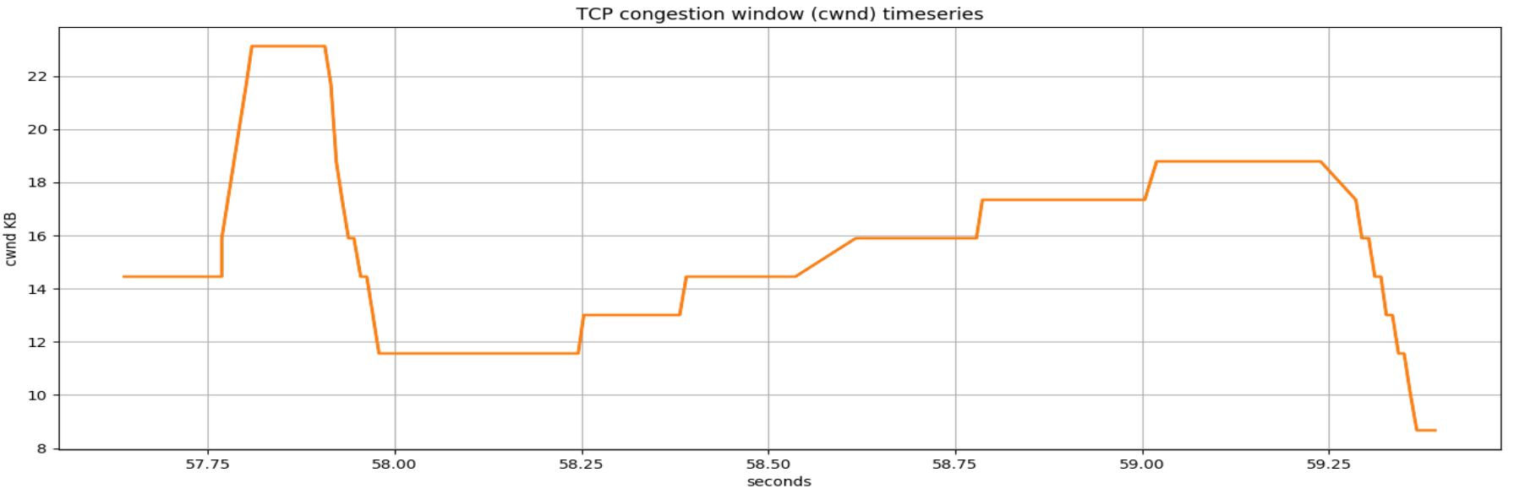

The figures here also generally follow a “saw-tooth” behaviour, although the frequencies here are higher (the figures reach their “peaks” faster) and their “peaks” are lower. This is because the buffer queue size is reduced, resulting in the buffers getting filled faster. Once the buffers are filled, loss occurs, prompting the reduction of size of cwnd. Therefore we can see that the “peaks” are reached faster and the figures fluctuate more frequently.

For the first figure, the switch queue occupancy has its peak at 100 packets.

For the second figure, the TCP CWND for iperf has a relatively consistent peak of about 32kB until about t = 57 to 60 seconds. This corresponds to the time where the wget happened, referring to the third figure where the TCP CWND for wget is relatively high.